**Lab 04 - Implement Virtual Networking**

***Mihail Elencevski***

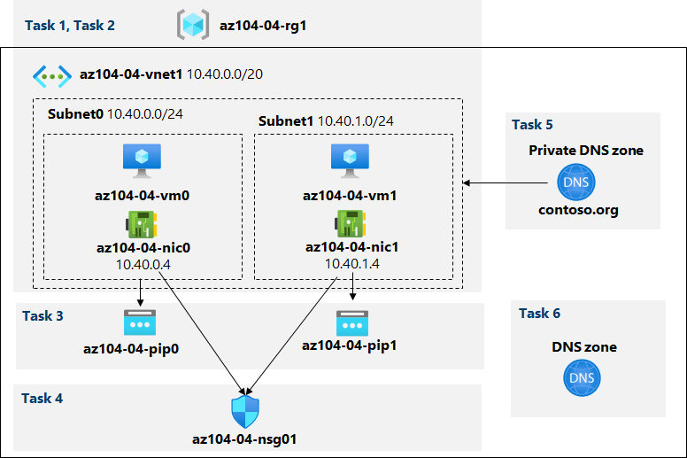

# *Task 1: Create and configure a virtual network*

This task requires me to create and configure a virtual network with multiple subnets by using the Azure portal.

The picture displays that I createt a Vnet and added 2 subnets.

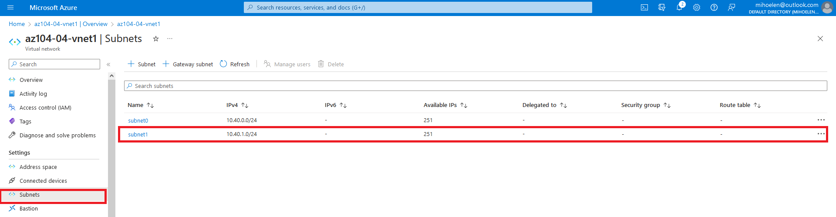

# *Task 2: Deploy virtual machines into the virtual network*

In this task, I need to deploy Azure virtual machines into different subnets of the virtual network by using an ARM template. I first uploaded the files that were requred and changed the password from the Parametar file.

Here I am deploying two virtual machines by using the template and parameter files:

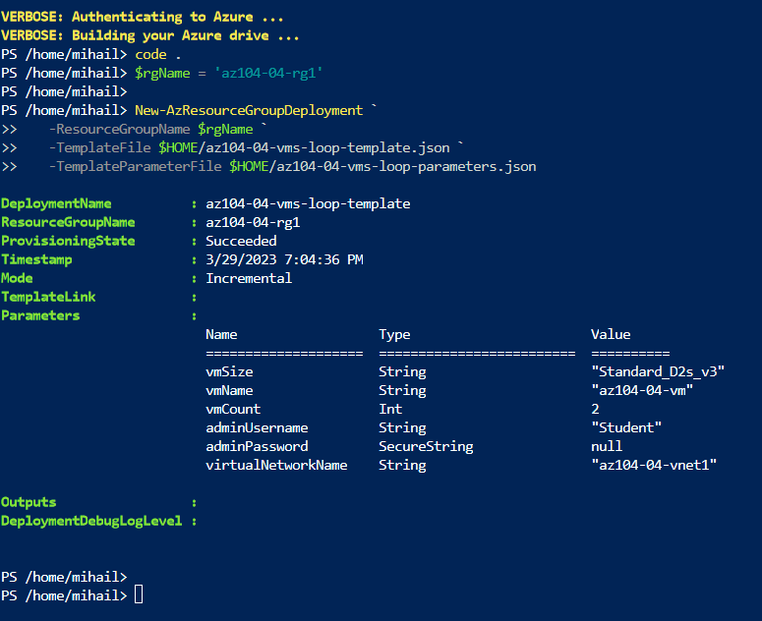

# *Task 3: Configure private and public IP addresses of Azure VMs*

In this task, I need to configure static assignment of public and private IP addresses assigned to network interfaces of Azure virtual machines.

Here in the picture I am veryfing that in the Vnet1 there are two connected devices. And I did the IP confiquration of each connected devices. Also I set the **Assignment** to **Static for each.**

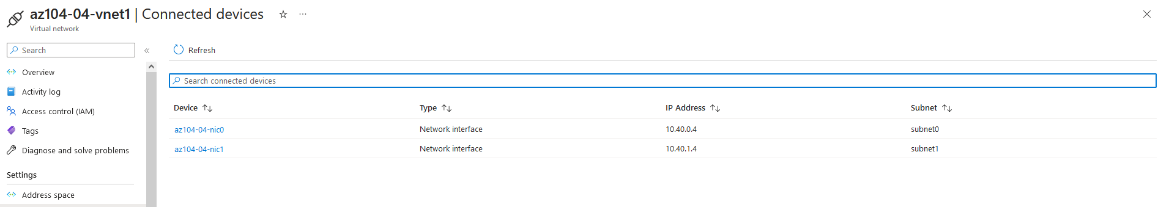

Here I noted the public IP address of VM0 and VM1.

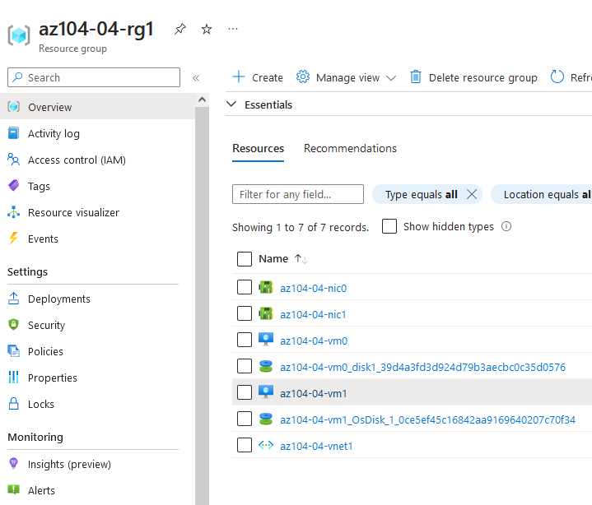

# *Task 4: Configure network security groups*

In this scenario, I am configuring network security groups in order to allow for restricted connectivity to Azure virtual machines.

Here I am noting that the connection attempt fails which the task required.

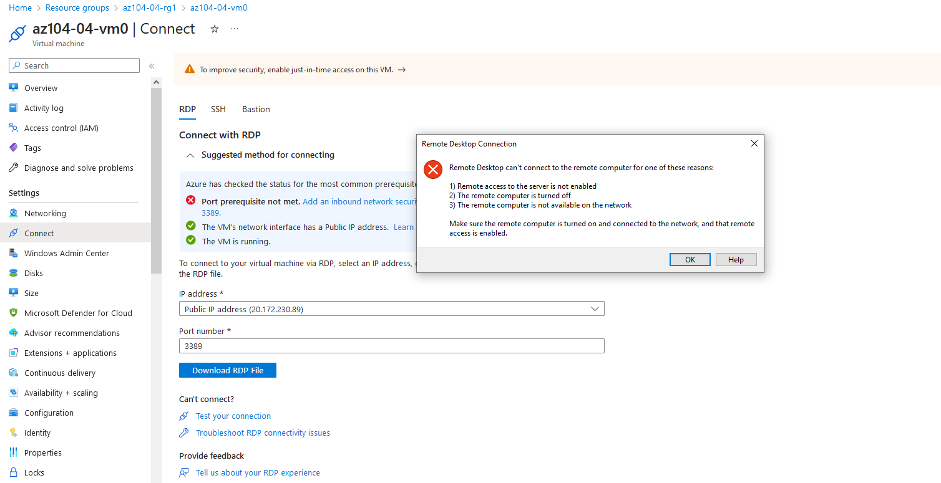

After the connection fails I stopped the VM0 and VM1. (this is done for lab expediancy).

Next, I created Network Security Group

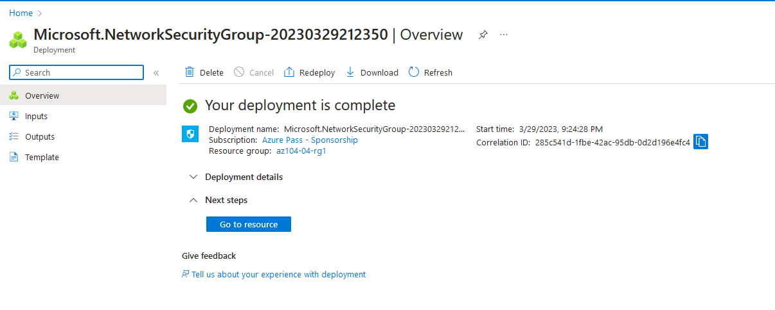

In this picture I am showing that I created an Inbound Security Rule with RDP service.

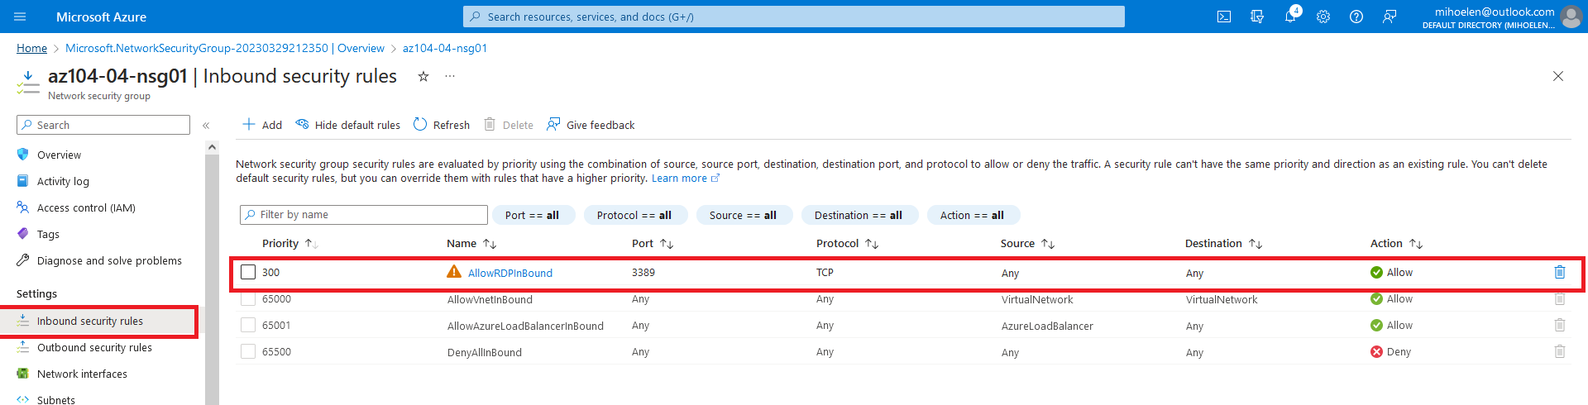

Here I associated the **az104-04-nic1** and **az104-04-nic0** Network Interfaces.

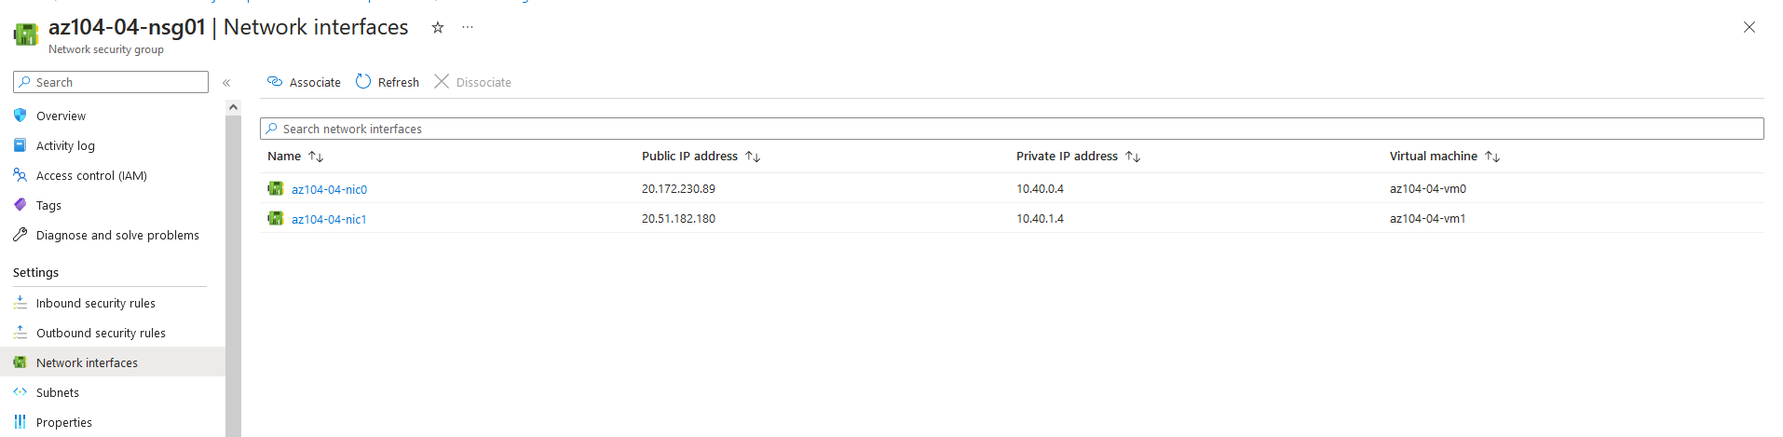

Here I am noting that I connected to the VM0.

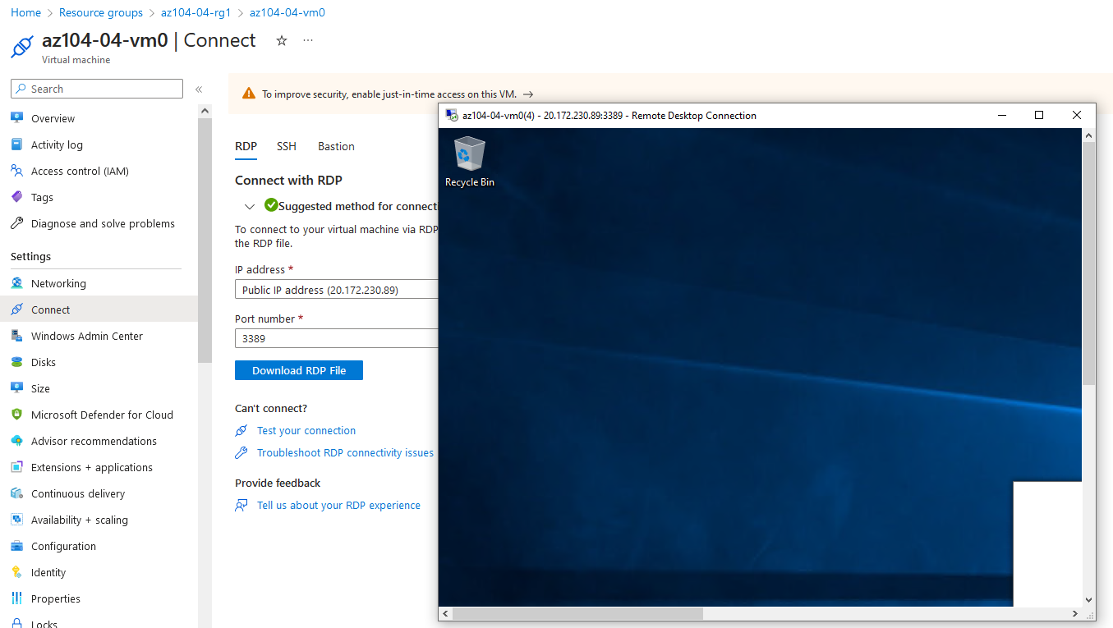

# *Task 5: Configure Azure DNS for internal name resolution*

In this task, I am configuring DNS name resolution within a virtual network by using Azure private DNS zones.

Here I created a Private DNS zone **contoso.org** and I created a Virtual Network Link (*Virtual network links provide secure communication between resources, allowing for better network organization and easier management*.)

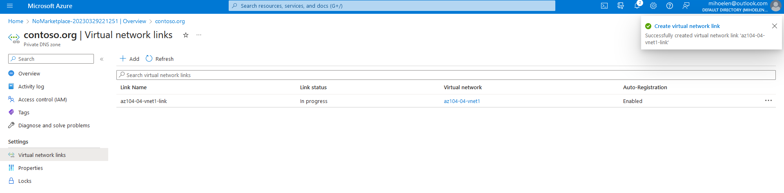

Here I am veryfing that the DNS records for **VM0** and **VM1** appear in the list of record sets as **Auto registered**.

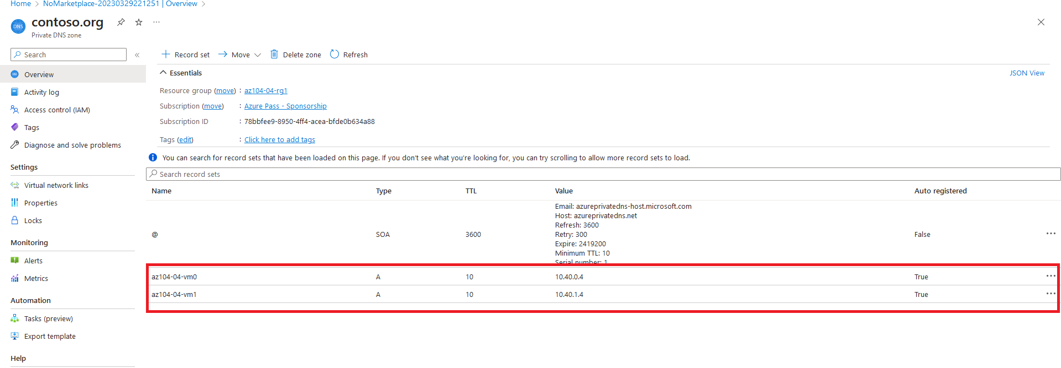

In the Remote Desktop session to **az104-04-vm0 I am verifing that the** output of the command includes the private IP address of **az104-04-vm1** (**10.40.1.4**).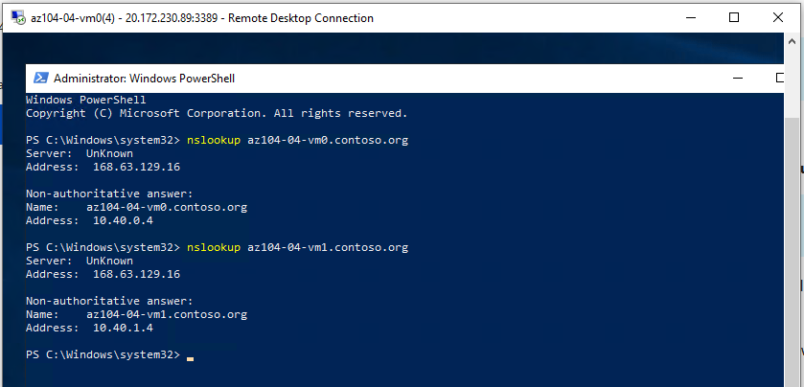

# *Task 6: Configure Azure DNS for external name resolution*

In this scenario , I am configuring external DNS name resolution by using Azure public DNS zones.

In the picture bellow I am proving that the output of the commands includes the public IP address of **az104-04-vm0 and az104-04-vm1.**

